HUV 6.C 4.2.2021

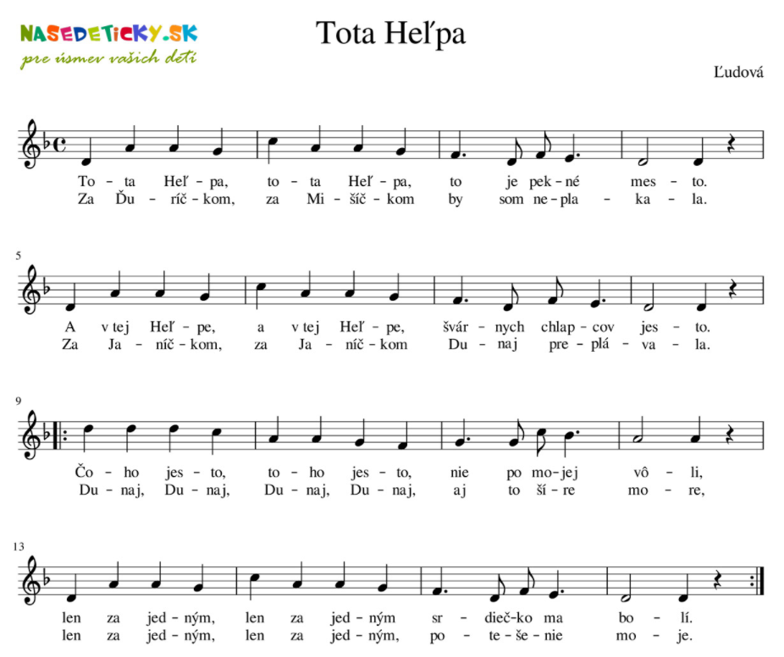

https://www.youtube.com/watch?v=6DdYz1oDzEc&ab_channel=MilanOrf%C3%A1nus

